### Current Activities

The remaining artefacts from Oslo have now arrived. They include some interesting pieces of equipment, including an electro-mechanical time synchronisation unit from around 1938, a differential pressure gauge and an environmental monitoring unit, which was used as part of the installation planning process to ensure a suitable environment for hardware. We now also have the typewriter and keypad for the 632 tabulator, the latter came with the first shipment.

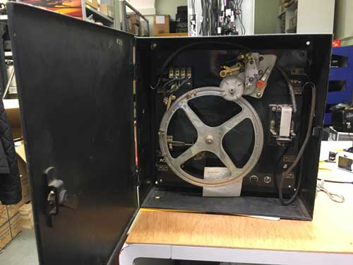 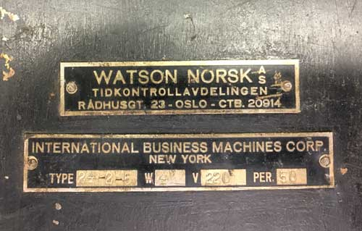

Time synchronisation unit, ca 1938. Built by Watson Norsk AS.

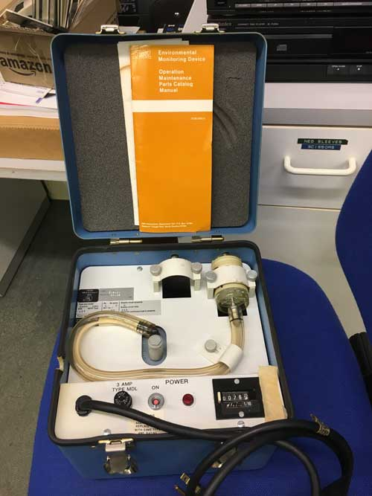 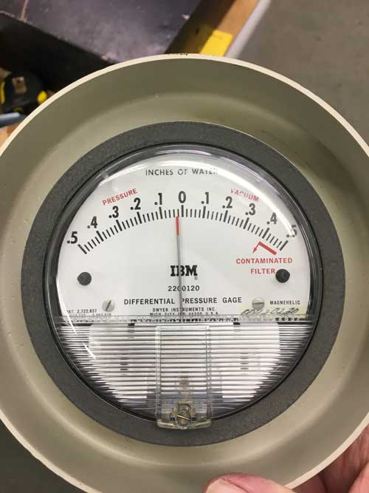

Environmental Monitoring Device Pressure Gauge

The System/370 console is now on display in the Hursley room. Although this is from a Model 155, it is our only artefact that remembers the Model 135 which was developed in Hursley.

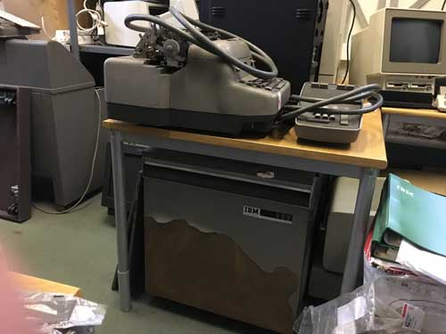 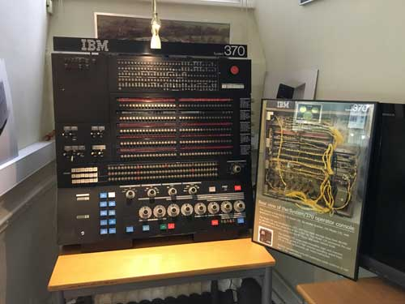

632 Tabulator in need of a respray S/370 Console

The web site is slowly catching up with developments. The [360 degree panoramas](http://hursley.slx-online.biz/views.asp) have been updated, I’m still having difficulties getting them to merge the frames properly but they do give an indication of what’s where.

A new page has been added describing what we know about the [IBM Pervasive Computing](http://hursley.slx-online.biz/pervasive.asp) initiative from the late 90s / early noughties. This programme could be called the Grandfather of IoT, with leading edge concepts that today we take for granted. We do have some of the artefacts from that programme, and may put together a Pervasive display sometime in the future.